Name ………………………………………..
Instructor ……………………………………
Course ……………………
Date …………………

INTRODUCTION
Aboriginal identity refers to whether the person reported being an Aboriginal person, that is first Nations merits or lnuk(Inuit) and being a registered or treaty Indian and being a member of a first nation or Indian band. The Aboriginals have always been the underdogs given the poor treatment and lack of justice provided by the Canadian government.
Due to this, I came up with a hypothesis which states that. If an Aboriginal identity was linked to the number of youth admission to correctional service then yearly there are more Aboriginal admissions.
The information provided in the report will either support or disapprove my hypothesis that, if Aboriginal identify was linked to number of youth admissions to correctional services then yearly there are more Aboriginal admissions compared to non-Aboriginal admissions.
The information provided in the report will either support or disapprove my hypothesis that, if Aboriginal identity was linked to number of youth admissions to correctional services then yearly there are more Aboriginal admissions compared to non-Aboriginal admissions.

PLAN AND METHODOLOGY
After stating my hypothesis it was necessary to gather enough data to roughly prove my hypothesis.
Data for both age groups for Aboriginal and non-Aboriginal people were indirectly age standardized according to their respective weighted average population for June 2006, 2007 and 2008. For Aboriginal people, the populations used were experimental estimates from the Australian Bureau of statistic (ABS 2009a).
For non-Aboriginal people, populations were calculated from weighted population over the period 2006 and 2008 (ABS 2009b), less the figures obtained for the Aboriginal population.
Method used was:
- Calculation of ratios
- Rate ratios
- Confidence intervals

- Calculation of rates.
Rates are presented as the number of admission per 100,000 people. The standardized ratio (SR) is also presented and shows the extent to which the rate for a particular group (e.g.Aborigical people) varies from the level expected if the rates for the south Australian population had applied in the region, remoteness area, age group, etc. for example, if the standardized ration for a region is 130, this means that the number of admissions in the region in 30 percent higher than would be the case. If admission rate for the state as a whole had applied in that region.
- Rate ratios
Rate ratios are used as the main comparator between admission rates for the Aboriginal and non-Aboriginal populations.

- Confidence intervals
They are reported at 95% level for the total Aboriginal to non-Aboriginal admissions for the total admission rates all diseases.

ANALYSIS
Data presented by socio-economic groupings of areas and remoteness.
- Based on ABS index of Relative socio-economics Disadvantage (IRSD), a summary measure of socio-economic factors the 2006 ABS census. Each SLA country in South Australia was assigned an IRSD score.
The SLAS were then ranked by that score and divided into five groups of approximately equal (20%) populations.
Rates and SRS are calculated for admissions for each of the five groups. The quintiles are based on the total population (as the standard for comparison) not by indigenous status or age group. The quintiles are based on country SLA’S not on SLAS across the whole state and reflects relative levels of disadvantage of the whole population, not solely children and not solely Aboriginal people.
- By remoteness, based on ABS remoteness classification.

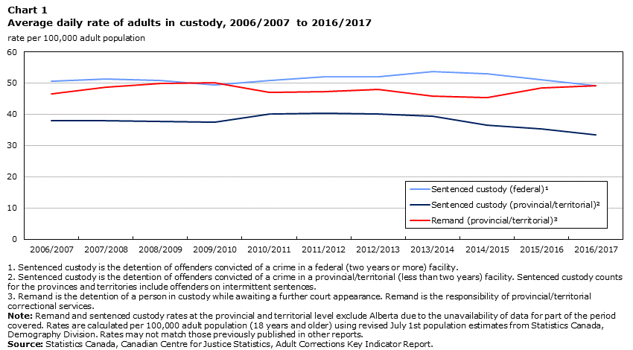

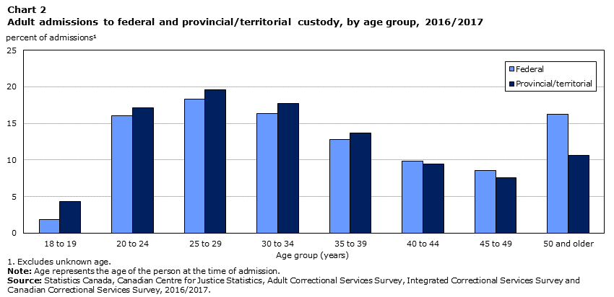

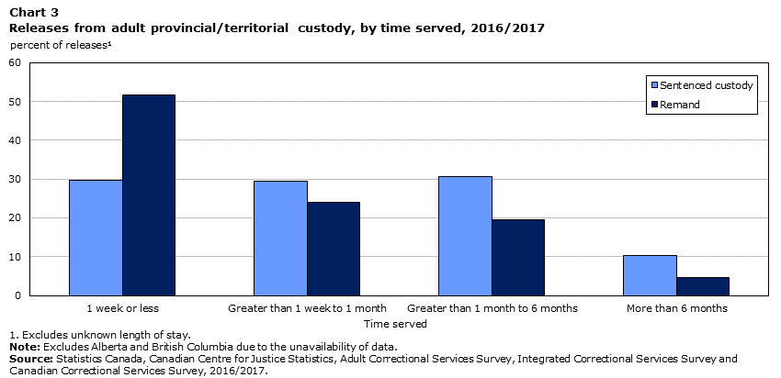

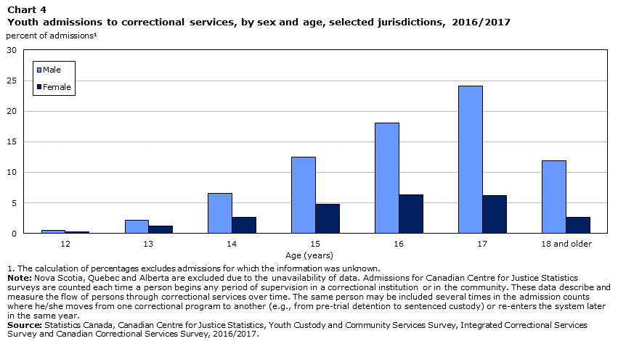

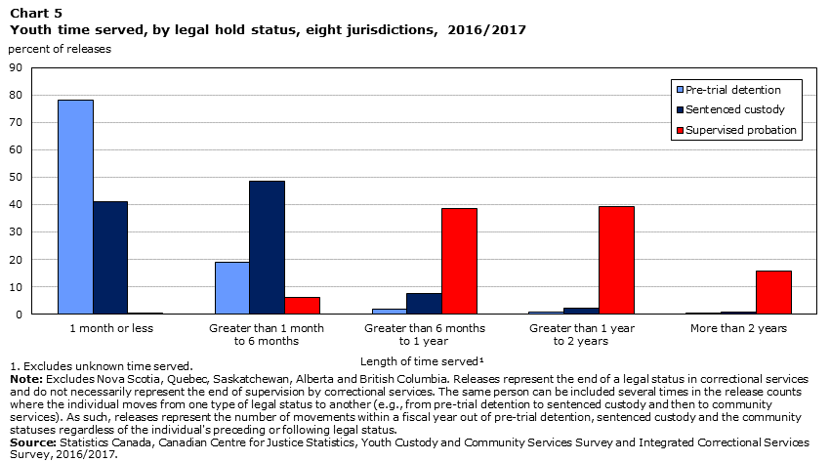
CONCLUSION

The aim of the report was to prove the hypothesis which states that, if an Aboriginal identity was linked to that number or youth admission to correctional servicethen yearly there is more Aboriginal admission from the data collected. I came up
with the following findings;

- Adult incarceration rate continues to decline.
- Adult in remand outnumber those in provincial/temporal sentenced custody.
- Most adults are under community supervision.
- Admission to adult correctional services decreases slightly.
- Adults who identify or an Aboriginal person are over represented in custody.
- Younger male adults are over represented in custody admssions.
Due to these findings, it is concluded that there is no increase in Aboriginals admission if Aboriginal identity was linked to the number of youth admission to correctional services.

REFERENCES
Chartrand, L., and K. Horn. 2016. A Report on the Relationship between Restorative Justice and Indigenous Legal Traditions in Canada. Department of Justice Canada. (accessed January 15, 2019).
Correctional Services Program. 2017. “Trends in the use of remand in Canada, 2004/2005 to 2014/2015.” Juristat.Statistics Canada Catalogue no. 85-002-X.
Criminal Code of Canada.RSC, 1985, c. C-46. (Current to December 12, 2018).
John Howard Society of Canada. 2018. “Financial facts on Canadian prisons.” John Howard Society of Canada Blog. (accessed January 15, 2019).
John Howard Society of Ontario. 2007. “Remand in Ontario. Second report to the Board, Standing Committee on prison conditions in Ontario.” John Howard Society of Ontario. (accessed January 15, 2019).
Legal Services Society. 2018. Gladue Report Guide. Legal Services Society of British Columbia.
Public Services Foundation of Canada. 2015. “Crisis in Correctional Services: Overcrowding and inmates with mental health problems in provincial correctional facilities.” Public Services Foundation of Canada. (accessed January 15, 2019).
R v. Gladue. 1999. SCC 26300, [1999] 1 S.C.R. 688.
Rudin, J. 2005. “Aboriginal Peoples and the Criminal Justice System.”Ipperwash Inquiry. (accessed January 15, 2019).
Savage, L. 2019. “Female offenders in Canada, 2017.”Juristat.Statistics Canada Catalogue no. 85-002-X.
Smith, P., C. Goggin and P. Gendreau. 2002. The Effects of Prison Sentences and Intermediate Sanctions on Recidivism: General Effects and Individual Differences. Public Works and Government Services Canada. (accessed on January 15, 2019).
Webster, C. M. 2015. ‘Broken Bail’ in Canada: How We Might Go About Fixing It. Research and Statistics Division. Department of Justice Canada.Accessed on January 15, 2019.
Youth Criminal Justice Act. 2003. Parliament of Canada. c .1, section 3(1).

